**LAB Mid DSA**

**NAME:AQSA ASGHAR**

**REG NO;SP22-BCS-012**

**SECTION:A**

**QNO;1**

**#include <iostream>**

**using namespace std;**

**int stack[100], n=100, top=-1;**

**void push(int val) {**

**if(top>n-1)**

**cout<<"Stack Overflow"<<endl;**

**else {**

**top++;**

**stack[top]=val;**

**}**

**}**

**void pop() {**

**if(top<=-1)**

**cout<<"Stack Underflow"<<endl;**

**else {**

**cout<<"The popped element is "<< stack[top] <<endl;**

**top--;**

**}**

**}**

**void display() {**

**if(top>=0) {**

**cout<<"Stack elements are:";**

**for(int i=top; i>=0; i--)**

**cout<<stack[i]<<" ";**

**cout<<endl;**

**} else**

**cout<<"Stack is empty";**

**}**

**int main() {**

**int ch, val;**

**cout<<"1) Push in stack"<<endl;**

**cout<<"2) Pop from stack"<<endl;**

**cout<<"3) Display stack"<<endl;**

**cout<<"4) Exit"<<endl;**

**do {**

**cout<<"Enter choice: "<<endl;**

**cin>>ch;**

**switch(ch) {**

**case 1: {**

**cout<<"Enter value to be pushed:"<<endl;**

**cin>>val;**

**push(val);**

**break;**

**}**

**case 2: {**

**pop();**

**break;**

**}**

**case 3: {**

**display();**

**break;**

**}**

**case 4: {**

**cout<<"Exit"<<endl;**

**break;**

**}**

**default: {**

**cout<<"Invalid Choice"<<endl;**

**}**

**}**

**}while(ch!=4);**

**return 0;**

**}**

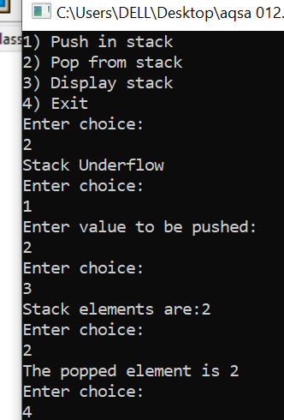

**QNO;02**

**#include <iostream>**

**using namespace std;**

**class Node {**

**public:**

**int data;**

**Node* next;**

**Node(int value) : data(value), next(NULL) {}**

**};**

**// Singly Linked List class**

**class LinkedList {**

**public:**

**Node* head;**

**LinkedList() : head(NULL) {}**

**// Function to insert a new node at the end of the list**

**void insert(int value) {**

**Node* newNode = new Node(value);**

**if (head == NULL) {**

**head = newNode;**

**} else {**

**Node* temp = head;**

**while (temp->next != NULL) {**

**temp = temp->next;**

**}**

**temp->next = newNode;**

**}**

**}**

**// Function to check if the linked list is a palindrome**

**bool SLL_SCND_FUNCTION_PALINDROME() {**

**if (head == NULL) {**

**return true; // An empty list is considered a palindrome**

**}**

**// Use a stack to store the first half of the linked list**

**Node* slow = head;**

**Node* fast = head;**

**Node* prev = NULL;**

**while (fast != NULL && fast->next != NULL) {**

**fast = fast->next->next;**

**// Reverse the first half of the list while traversing**

**Node* nextNode = slow->next;**

**slow->next = prev;**

**prev = slow;**

**slow = nextNode;**

**}**

**// If the total number of nodes is odd, move slow one step forward**

**if (fast != NULL) {**

**slow = slow->next;**

**}**

**// Compare the first half with the second half**

**while (slow != NULL) {**

**if (prev->data != slow->data) {**

**return false;**

**}**

**slow = slow->next;**

**prev = prev->next;**

**}**

**return true;**

**}**

**};**

**int main() {**

**LinkedList list;**

**list.insert(1);**

**list.insert(2);**

**list.insert(2);**

**list.insert(1);**

**if (list.SLL_SCND_FUNCTION_PALINDROME()) {**

**cout << "The linked list is a palindrome." << endl;**

**} else {**

**cout << "The linked list is not a palindrome." << endl;**

**}**

**return 0;**

**}**